**INTERNSHIP REPORT**

**KSEB 220 kV SUBSTATION – KOTHAMANGALAM**

**2 July 2024 – 6 July 2024**

Submitted by, **HANNA ASHRAF** Reg No: **MAC22EE055**

# JOYAL SAJAN Reg No: MAC22EE063 MEGHANA ELDHOSE

Reg No: **MAC22EE067**

# NIYUKTH R

Reg No: **MAC22EE083** **PRANAV VINOY**

Reg No: **MAC22EE088**



**Department of Electrical and Electronics Engineering**

Mar Athanasius College of Engineering Kothamangalam

July 2024

# ACKNOWLEDGEMENT

It is a great pleasure to acknowledge all those who have assisted and supported us for successfully completing our internship at 220 kV Substation, Kothamangalam, KSEB.

First of all, we thank God Almighty for his blessings as it is only through his grace that we were able to complete our internship successfully.

We take this opportunity to extend our sincere thanks to our faculty advisor, Prof. Smitha Paulose, Assistant Professor, Department of Electrical & Electronics Engineering and all other members of the Department of Electrical & Electronics Engineering for their constant support and immense contribution for the success of our internship.

We also extend our sincere thanks to Mr. Pradeepkumar K. S, Assistant Engineer, 220 kV Substation, Kothamangalam and Mr. Bimal Surendran, Sub Engineer, 220 kV Substation, Kothamangalam for their valuable guidance and support and we also thank all the other engineers and employees in the organisation for their valuable support for the successful completion of the internship.

We are also grateful to Dr. Siny Paul, Head of Electrical & Electronics Engineering Department for her valuable guidance.

We are deeply indebted to Dr. Bos Mathew Jos, Principal, Mar Athanasius College of Engineering, for his encouragement and support.

# CONTENTS

Chapters Page No.

**CHAPTER 1.** INTRODUCTION 4

**CHAPTER 2.** SINGLE LINE DIAGRAM 5

**CHAPTER 3.** COMPONENTS OF THE SUBSTATION 7

**CHAPTER 4.** CONCLUSION 10

# CHAPTER 1

## INTRODUCTION

The Substation is a part of an electrical generation, transmission and distribution system. It transforms voltage from high to low and performs several other important functions such as:

* Controlling the exchange of energy
* Load shedding and prevention of loss of synchronisation and maintaining the system parameters within targeted values
* Voltage control and protection of the transmission line
* Fault analysis and providing reliable supply
* Establishing economic load distribution

The 220 kV Substation, Kothamangalam is with a transformer capacity of 2*100 MVA at 220/110 kV level and 2*20 MVA at 110/11 kV. Kothamangalam substation is a grid substation which is having three 220 kV feeders, one from the power house, Idukki (2IDKM), another from generating station in Pallivasal (2PVKM) and the other from Aluva (2KMAL). 220/110 kV transformers (three phase autotransformers) and 110/11 kV transformers (star - star) are Telk made. There are eight 110 kV feeders connected to the 110 kV bus. They are Marady (1KMMR), Koothattukulam (1KMKK), Odakkali (1KMOD), Aluva (1KMAL), Idamalayar (1IMKM), Bhoothathankettu (1BTKM), Edathala (1KMET), Adimali (1ADKM).

There is a double bus system with bus couplers for both 220 kV and 110 kV buses. The bus bar protection is implemented in 220 kV bus systems. Normally all feeders are in the same bus. There are 14 11 kV feeders such as Cheruvattoor, Cson, Pothanikad, Colony, Puthuppady, Town, Keerampara, Spare, Kozhippilly, Kavalangad, Plamudy, Nellikuzhy, Auxiliary and Bhoothathankettu.

# CHAPTER 2

## SINGLE LINE DIAGRAM

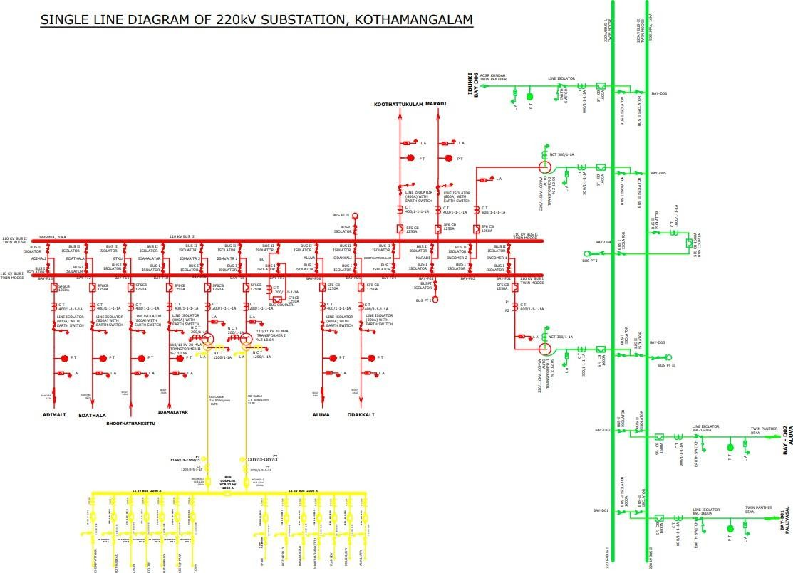

The 220 kV Substation, Kothamangalam is with a transformer capacity of 2*100 MVA at 220/110 kV level and 2*20 MVA at 110/11 kV. Kothamangalam substation is a grid substation which is having three 220 kV feeders, one from the power house, Idukki (2IDKM), another from generating station in Pallivasal (2PVKM) and the other from Aluva (2KMAL). Each feeder is protected with a distance protection scheme along with overcurrent and earth fault protection. ACSR Kundah twin panther conductor is used for the feeders. From the terminal tower, the feeders enter the 220 kV yard where it is connected to a lightning arrester. Then the feeder is connected to PT, line isolator with earth switch for extra security. Then the line passes onto a CT with a ratio of 800/1-1-1-1 A. The line is then connected to the 220 kV busbar via an SF6.

SF6 CB is of rating of 1600 A. Before the line passes onto a 100 MVA transformer it passes through a CT with a ratio of 300/1-1-1-1 A. There is a double bus system with bus coupler for both 220 kV and 110 kV buses. Twin moose is the conductor used for the buses. The bus bar protection is implemented in 220 kV bus systems. Bus isolators are also present. 220/110 kV transformers (three phase autotransformers) and 110/11 kV transformers (star - star) are Telk made. Then the line passed is stepped down to 110 kV and passes onto a CT with a ratio of 600/1-1-1-1 A. Wolf conductor is used for 110 kV lines. From 110 kV bus bars, the 110 kV passes onto a CT with a ratio of 400/1-1-1-1 A. SF6 CB has a rating of 1250 A.

Before the line passes onto 20 MVA transformers it passes through a CT with a ratio of 200/1-1-1-1 A. UG cable of 2 x 500 sq.mm XLPE is used after stepping down to 11 kV before connecting them to 11 kV buses. The 11 kV bus inside the panel is fed from the transformers through an underground cable network. There are eight 110 kV feeders connected to the 110 kV bus. 3*300 XLPE conductors are used for 11 kV lines from 11 kV buses. CB of 1200/5-5-1-1 A rating is used before connecting to 11 kV bus. The eight 110 kV feeders are Marady (1KMMR), Koothattukulam (1KMKK), Odakkali (1KMOD), Aluva (1KMAL), Idamalayar (1IMKM), Bhoothathankettu (1BTKM), Edathala (1KMET), Adimali (1ADKM). There are 14 11 kV feeders such as Cheruvattoor, Cson, Pothanikad, Colony, Puthuppady, Town, Keerampara, Spare, Kozhippilly, Kavalangad, Plamudy, Nellikuzhy, Auxiliary and Bhoothathankettu. If tripping occurs, the phase responsible for it is also indicated along with the type of fault in the control panel board. SCADA software is used for the substation automation. The control, monitoring and metering of the electrical parameters occurs in a substation.

# CHAPTER 3

## COMPONENTS OF THE SUBSTATION

A static electrical machine used for transforming power from one circuit to another circuit without changing frequency is termed a Power transformer. The transformers are generally used to step down or step up the voltage levels of a system for transmission and generation purposes. The main components are the following:

### Transformers and Accessories

Station has two 100 MVA 220 kV/110 kV autotransformers and two 20 MVA 110 kV/11 kV single phase transformers connected in star-star configuration. All transformers are provided with the following protections:

* 1. Differential protection
  2. REF protection on both HV and LV side
  3. Over current and Earth Fault protections on both HV and LV side
  4. Buchholz protection

### Main accessories

* Main tank and Conservator tank

Also known as the Transformer tank, holds the windings and its insulating medium. The tank must be air tightly sealed for it to isolate its content from any atmospheric contaminants. It is used to provide enough space for the expansion of oil when the transformer is loaded or when the ambient temperature changes.

* Cooling Fans

It helps in dissipating the heat that is generated in its oil insulation. For higher efficiency, a cooling mechanism is required since the capacity of the transformer is dependent on its temperature.

* Buchholz Relay

It is a gas-activated relay. It is a very sensitive gas and oil-operated instrument which safely detects the formation of gas or sudden pressure inside the transformer oil. There are two actions; alarm and trip. There are two Buchholz relays viz main Buchholz and OLTC Buchholz, one connecting main tank to conservator tank and the other connecting OLTC tank and conservator tank respectively.

* OLTC

On Load Tap Changers (OLTC) are the main part of the regulation of power transformers. It changes the turns ratio of a transformer by adding or subtracting turns to either primary or secondary winding.

* Silica Gel and Breather

A breather is a device used for absorbing the moisture content of oil and sucked air. Silica gel is a chemical material that is filled in the breather. Before absorption its colour is Blue and after absorption, it turns Pink. The oil below the breather absorbs the dust particles.

* PRV

Pressure Release Valve is used for releasing the pressure inside the transformer as a safety method.

* Wheel

It helps in transportation and balancing of the transformer.

### Lightning Arresters

These are provided on the line portions of 220 kV side, 110 kV side, transformers and 11 kV side. Notice the needle whether in the green zone while inspection. If it goes to the red zone, it should be intimated.

### Station Auxiliary Supply

Auxiliary supply is 11 kV. The station auxiliary load is mainly for station lighting, battery chargers, OLTC panel, pumping etc.

### Station Battery

For the proper working of the substation, DC voltage is important. The relays and panels are working in DC. A substation cannot be operated in the absence of a DC supply. There is a control room and a battery system. Alarm and other necessary indications are provided in case for the main failure, over and under voltage.

The station battery provided in the substation is 110 V DC, 400 AH capacity. The DC system consists of two Float cum Boost chargers and two battery banks each of 110 V, 400 AH, Plane type for control and protection circuits of the 220 kV substations. Float charging the associated Lead - Acid Batteries at 2.25 V per cell while supplying the DC load. There are 55 cells and they are of EXIDE type and Chloride Power Systems & Solutions Ltd.

### Fire Extinguishers

Different types of fire extinguishers are used here for different types of fires.

### Circuit Breakers

For the protection of the substation and its components from overcurrent or overload due to a short circuit or any other fault, the faulty section is disconnected from the healthy section either manually or automatically. If once the fault is rectified, then again, the original circuit can be rebuilt manually or automatically.

### Isolator

Isolator is a manually operated mechanical switch that isolates the faulty section or the section of a conductor or a part of the action of substation meant for repair from a healthy section in order to avoid the occurrence of more severe faults. Bus isolators and line isolators are present. Both isolators are manually operated with 2 handles provided for them in the switchyard under the respective isolators. Care should be taken while operating isolators because isolator’s contacts if not properly made may cause severe arching. Care should be taken to operate the isolators only in no load condition, i.e. breakers should be opened before operating the isolators.

### Current Transformer

CTs are used for protection, measurement and control in substation. A high voltage CT may contain several cores, each with secondary windings for different purposes such as metering, control or protection. It is used for measuring and controlling current. To the primary side, supply from the line is given and to the secondary side the ammeter is connected and is short

- circuited.

### Potential Transformer

PT is used for stepping down the system voltage to a safe value which can be fed to low rating metres and relays. It is used for measuring and controlling voltages. To the secondary side, voltmeter is connected.

### Earth Switch

One earth switch is provided with each feeder coupled with the line isolator for the purpose of earthing the feeder while on permit work. Ensure that the feeder is not charged before earthing. The operation of the earth switch is also manually with the handle provided in the mechanism box.

# CHAPTER 4

## CONCLUSION

The training at the 220 kV substation gave us a great insight into the real time monitoring during the distribution of power. We got an insight into the engineering fields, especially of power distribution study. The study provided useful notions into the substation and is functioning. Power is delivered to the customers through a large network of transmission and distribution. At a power station, electricity is stepped up to higher voltages to facilitate easier transmission and at utilisation level it is stepped down to suitable voltages by the substations. We were able to view and understand the works of an engineer and how to deal with engineering problems and challenges in real life situations. We gained knowledge by practice and it was a great experience. The training helped us to improve our technical skills. The details about the functioning of the substation was well explained by the engineers there. We got more enlightened about the theoretical aspects and the practical applications of these aspects were more instilled in us when we were taken to the yard. In a nutshell, it was indeed a knowledge packed training.

